UI Engineer Assignment

**Problem**: VP of Sales wants to view an organizational hierarchy displaying employee’s and their sales performance on a TV for them to monitor.

* Each sales member has a status with a colour associated with it. Critical = red, warning = yellow, and normal = green. They want to display the status with the colours.
* Since it’s only being displayed on a TV the UI cannot be interacted with.
* Display is to be refreshed every 30 minutes to display latest hierarchy
* VP wants to be able to see by a quick glance the how the organization is doing.

Sample Hierarchy:

* VP of Sales [critical]
  + Sales Manager (North America) [critical]
    - Sales Lead (Canada) [normal]
      * Sales Representative (Toronto) [normal]
      * Sales Representative (Vancouver) [normal]
    - Sales Lead (USA) [critical]
      * Sales Representative (New York) [warning]
      * Sales Representative (Dallas) [critical]
      * Sales Representative (Los Angeles) [critical]
  + Sales Manager (Europe) [warning]
    - Sales Lead (Germany) [warning]
      * Sales Representative (Berlin) [normal]
      * Sales Representative (Frankfurt) [critical]
    - Sales Lead (Italy) [normal]
      * Sales Representative (Milan) [normal]

Display I would use:

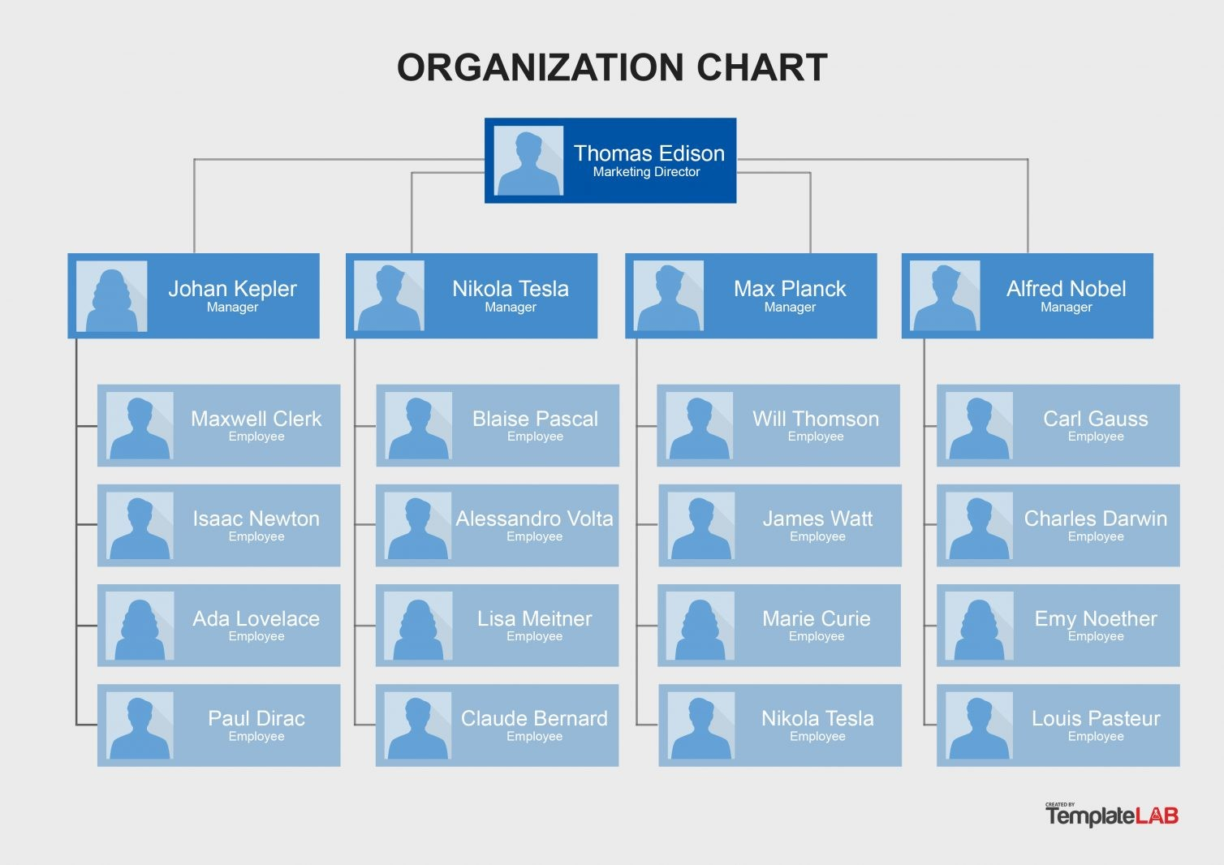

This is the hierarchy chart I liked the most, with the blue replaced with the associated status colour for each employee’s status and with the colour being prominent so the VP should be able to see immediately how many ppl are red, I will not be adding an image for each sales person here.

In React, I would create a list that would take the data and from there display the Hierarchy tree with the associated status colour.

My Component imports the data and from there it uses that data to create the tree so there isn’t a hard coded way of the tree being made in a sense so this list can take in different types of data. The thing is the data attributes like .**name**, **.title**, and .**status** and **.children** would have to be the same attribute names from the data that is being imported or else if the source data attributes are incorrect then the tree will error out.

A thing to take note of is that depending on the hierarchy some of the sales employee’s will spill over to the right side of the screen past it or it will be further down and since the UI isn’t interactable since it’s on a Tv you have to set a type of periodic scroll so that all the data is visible to the VP of Sales.